Wellington Hockey Association

COVID – 19 Response Plan

Version History
Version | Date | Author(s) | Description
1 | 08/05/2020 | L.Jones, WHA Team, G.Jeune | Initial version of response plan
1.1 | 10/05/2020 | L.Jones, WHA Team, G.Jeune | Amendments based on level 2 guidance

Contents | Page(s)
Introduction
Communication
Contact Tracing
Gathering Sizes and Bubbles
Physical Distancing and Hygiene
Cleaning
Personal Protective Equipment
Worker and Volunteer Health (including wellbeing)
Responding to a Suspected or Confirmed Case of COVID-19
Monitoring of Controls
Appendix 1 – Risk Assessment and Control Plan
Appendix 2 – Risk Matrix
Appendix 3 – Monitoring Guidance
Appendix 4 – Personal Health Flowchart
Appendix 5 – Cleaning Regime Example
Appendix 6 – Work Safe NZ Template Assessment
Appendix 7 – Worker Re-induction Fact Sheet
Referenced Material

Introduction
This response plan has been developed as part of the transitions between alert levels to mitigate the transmission risk of COVID – 19 and encourage a safe and respectful work environment with effective communication channels for all workers and stakeholders.
It is designed to provide guidance to and support Wellington Hockey Association (WHA) management and team members in the delivery of hockey within the Wellington Region, along with creating a consistency in approach.
WHA’s goals under Alert level 2 are:

- Meet the Government requirements regarding Alert Level 2 including restricting gathering sizes
- Stop COVID-19 coming into the WHA locations
- Achieve contact tracing across open WHA locations
- Stop it spreading within the workplace through hygiene practices, cleaning of equipment and surfaces (including turf surfaces)
- Stop COVID-19 from going home
- Protect staff when they are on other site/facilities
- Keep our business operational and viable
- Provide assurance to staff of the decisions / processes that we have put in place
- Provide assurance to the hockey community and other parties.

The content has been developed to align with the Ministry of Health, Work Safe New Zealand and Sport New Zealand guidance available. There is an expectation that the response plan will be actively monitored and reviewed as part of engagement with our workers, stakeholders and ahead of transitions between alert levels.

Communication
Communication is a critical part of this response plan. WHA will continue to focus on engaging externally and internally during the changes in alert levels.

Externally WHA will be focused on:
- Connecting to Hockey NZ, Sport Wellington and local working groups
- Providing regular updates to the hockey community (even when there is no update)
- Continuing to use multiple platforms to engage and inform our hockey community (including social media).

Internally WHA will be focused on:

- Providing regular updates to WHA workers and the Board Chair
- Communicating regularly with WHA workers, volunteers and tenants across multiple sites, including people who are working from home
- Compile a register of WHA workers, volunteers and tenants to ensure we have current contact details for all of them
- Ask WHA workers, volunteers and tenants to update their personal contact details
- Avoiding face-to-face communication as much as possible
- Using technology platforms to stay connected to your teams (Phone, Skype, Zoom)
- Cancelling non-critical face-to-face meetings and implementing an alternative process for maintaining communication (notice boards or meetings with smaller numbers of people so that physical separation can be maintained)
- For any large meetings do so outdoors or in large spaces to ensure people stay at least two metres apart
- For all other parties engaged to come onto a WHA site, WHA will communicate the identified hazards and control measures (as from appendix 1).

This continues to be an unsettling and rapidly developing situation and so it is important that we are
able to maintain regular contact with all of our people. What’s really important is to stay connected
and check in on how they are doing: physically, mentally and socially.

Contact Tracing
Contact tracing is the identification of individuals that have come into contact with people who have been diagnosed with COVID-19, and it is a fundamental precaution taken against the spread of the virus in the community.
Wellington Hockey Association will implement a system to record contact details of all people involved, or attending for contact tracing purposes in case of a COVID-19 outbreak.
The register will be kept in both a hard copy and electronic and must record all individuals who have visited WHA facilities. WHA will work with hockey clubs to establish effective means for capturing attendance during training sessions and on game days.
The register will include the following information for each individual:
- Date
- Time
- Full name
- Address
- Phone
- Email addresses.
Guidance issued by the Ministry of Health requires that these details should be kept for four weeks, and that the information collected may only be used for the purpose of contact tracing at the request of the Ministry of Health or local district health boards.
Care should be taken in the maintenance of the guest register, with the following issues being addressed:
- Transparency: Individuals must be made aware of the reason for the register, and what will happen to the information. It is suggested that the following wording be used:
“This information is being collected to assist in the management of the COVID-19 pandemic. It will be given to the Ministry of Health and/or the District Health Board on request in the event that it is required for contact tracing purposes. We will not use it for any other purpose, and will destroy it after four weeks. It will be kept here at [name of the establishment]. You have a right to access and correct any information we hold about you.”
- Security: the completed information will be kept safe, in a locked access location. We will prevent individuals from seeing the information provided by others on the register by encouraging the use of the digital register or on the physical register covering the others’ details when later individuals sign in
- Retention and disposal: we will securely dispose of the register after four weeks. Not just throw it in the bin.
- Use: The sole purpose of the register is for contact tracing. We will not use the information for any other purpose, such as building our mailing list
- Disclosure: We will not give the register to other parties, or let individuals flick through it.
Should there be a suspected or confirmed COVID-19 case among someone who visited a WHA facility, a WHA representative will contact Healthline’s dedicated COVID-19 hotline on 0800 358 5453. Health authorities will then decide whether to contact anyone else linked to the suspected or confirmed case.
For further details or have any further queries regarding contact tracing and the Privacy Act 1993 please contact the Privacy Commissioner on 0800 803 909 (Monday to Friday, 10am to 3pm).

Gathering Sizes and Bubbles
Under alert level 2 we have a requirement to limit the number of people at sporting gatherings to 10 people per group and all groups must be spaced at least 2 metres apart (not including players, officials or support staff).

In the WHA context this means;
- No more than 10 people per group(not in the playing/training teams) at Fraser Park, Elsdon, Maidstone or NHS 1,2 and 3.

No supporters allowed under Level 2

Bubbles
The term ‘bubble’ has been largely used to define the people who share your household and/or closely connected to. As WHA workers begin to return to our places of work, we will be adding another bubble to our lives, our work bubble.

This work bubble represents people who we will be in relative close proximity (in the same office/building). When connecting to the hockey context, training groups/teams will naturally be forming their own work (hockey) bubble.

As we continue the return to work under level 2 and beyond, there will be situations where we will be working across multiple work bubbles. This is more obvious when we are engaging with other work bubbles (like Contractors, Suppliers, Tenants and other Organisations).

There are a number of key actions to be undertaken for WHA Management to undertake relation to work bubbles;
- Review work activities and establish work teams to form work bubbles and communicate this to workers
- Plan work activities to avoid close work activities and minimise cross over of work bubbles on site
- Establish separate work areas for your people
- Planned staggered start times, meal times and rest breaks to avoid intermingling between bubbles (where applicable)
- Identify situations where cross over between work bubbles will take place (both on and off site).

For workers, we also have some key responsibilities in relation to work bubbles;
- Stay within your work bubbles, where you identify a situation where a cross over will occur, get in touch with your manager and ensure that the controls defined within this response plan are applicable.

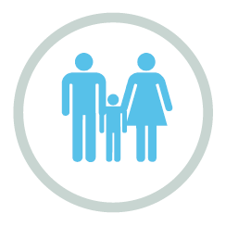 | 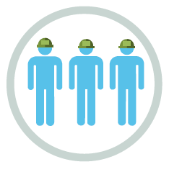 | 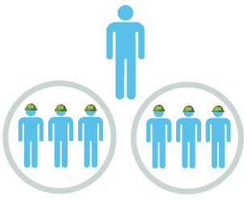
Home Bubble  Your home bubble refers to  those you live with. Your family  / people you have been  “isolating” with during the Alert  Level 3 & 4 Lockdown Period | Work Bubble  Your work bubble refers to the  team / crew that you will be  working with (in relative close  proximity) while on site / in the  office  For hockey clubs, they will naturally be creating hockey bubbles within their teams | Persons Working Across  Bubbles  We also need to consider that some  workers may have to move between Work Bubbles to undertake activities.  This is also the situation when working with other hockey bubbles and other organisations when we head to another work site.

Physical Distancing and Hygiene
Physical distancing, sometimes known as “social distancing”, is about keeping a safe distance from others. Physical distancing means remaining two metres away from other people. This is important to help protect us from COVID-19, which spreads via droplets from coughing and sneezing. Staying two metres away from others is an effective measure.

General working arrangements:
- Keep team sizes as small as possible
- Keep a record of who is in each team every day as you may be required to track back for contact tracing (template in appendix 8) - Sue keep a record?
- Workplace and work sites are to be segregated into zones (or by other methods) as much as possible to keep different teams physically separated at all times
- Where practical, and based on the alert level, all office employees supporting a project work remotely
- When using a vehicle, the Cleaning Guide must be followed
- When using a vehicle, limit this to one person per vehicle where possible.

External interfaces
- One employee nominated to receive deliveries
- Keep the engagement with the couriers / freight forwarders as brief as possible
- Ask for paperwork to be emailed rather than handed over as much as possible
- Use your own pen to sign any documentation
- If unavoidable, then either wear gloves when handling the item or wash hands before and after handling said items
- Delivery drivers should remain in their vehicles if the load will allow it and must wash or clean their hands before unloading goods and materials.

Site entry and exits:
- Only employees’ or essential volunteers to access Wellington Hockey Association offices
- Limit visitors to sites wherever possible
- Monitor site access points to enable physical distancing
- Where entry systems that require skin contact e.g. door handles are used, the Cleaning Guide must be followed
- All workers to wash or clean their hands when entering and leaving the site
- Regularly clean common contact surfaces in reception, office, access control and delivery areas e.g. Printers, screens, telephone handsets, desks, door handles particularly during peak flow times
- Undertake a remote induction on this response plan before return to work
- Any sign in registers should be recorded by one person where possible – do not pass material around the group and minimise contact with any screens.

Meetings:
- Only absolutely necessary meeting participants should attend
- Attendees should be one metre apart from each other
- Rooms should be well ventilated / windows opened to allow fresh air circulation
- Hold meetings in open areas where possible
- Meetings are to be held through teleconferencing or video conferencing where possible.

Avoiding close working:
- Risk assessments and method statements must be updated to include COVID-19 control measures.
- Plan all work to minimise contact between workers
- If it is not possible or safe for workers to distance themselves by one metre for a work activity the following steps must be satisfied: Are the works essential and do they need to be carried out now? If not, the works should not be carried out
- If they do need to be carried out additional control measures must be in place. Additional controls could include; wearing disposable overalls, wearing protective equipment, short duration works, reducing the number of workers involved
- Reusable PPE should be thoroughly cleaned after use and not shared between workers
- Single use PPE should be disposed of so that it cannot be reused
- Stairs should be used in preference to lifts on sites
- Where shared hockey equipment must be used, reduce the amount of usage where practicable - and disinfect after use
- Regularly clean touchpoints, doors, buttons etc.

Toilet facilities:
- Wash hands before and after using the facilities
- Enhance the cleaning regimes for toilet facilities particularly door handles, locks, toilet flush and sanitary bins
- Provide suitable and sufficient rubbish bins for hand towels with regular removal and disposal.

Eating arrangements:
- If you need to leave Wellington Hockey Association premises for any reason, follow site entry procedures on return
- Dedicated eating areas should be identified on site to reduce food waste and contamination
- Break times should be staggered to reduce congestion and contact at all times
- Hand cleaning facilities or hand sanitiser should be available at the entrance of any room where people eat and should be used by workers when entering and leaving the area
- The workforce should be asked to bring pre-prepared meals and refillable drinking bottles from home
- Workers should sit 2 metres apart from each other whilst eating and avoid all contact
- Shared crockery, eating utensils, cups etc. shall be cleaned after use and personal hygiene protocols followed
- Tables should be cleaned between each use
- All rubbish should be put straight in the bin and not left for someone else to clear up
- All areas used for eating must be thoroughly cleaned regularly through the day, including chairs, door handles
- Coffee machines and water fountains use shall be limited
- Consider numbers on site for site facilities as physical distancing may require additional space/facilities.

Smoking:
In addition to the Wellington Hockey Association smoking policy:
- Smokers/vapers must use designated areas or do so off-site and butts are to be placed in the designated receptacle. Hands must be washed before and after smoking
- Stand so that smoke or vapour produced is not going into another person’s breathing zone.

General hygiene:
- Each worker must sanitise their hands with hand sanitiser or soap and running water before entry onto site, use warm water if available
- Set up a specific place near the entry of the site for handwashing and/or sanitising. Keep things simple and allow for the environmental conditions (wind and rain)
- Any personal items brought to site by workers must be segregated (kept separate from other workers items)
- Individual PPE for workers must be kept separate from other workers PPE and cleaned correctly as per the Cleaning Guide
- All eating and drinking utensils to be cleaned by the user. Have paper towels accessible to dry.

Hand washing:
- Provide additional hand washing facilities to the usual welfare facilities on large, spread out sites or significant numbers of personnel on site
- Ensure soap and fresh water is readily available and kept topped up at all times
- Provide hand sanitiser where hand washing facilities are unavailable
- Regularly clean the hand washing facilities and check soap and sanitiser levels
- Extra supplies of soap, hand sanitiser and paper towels shall be maintained and securely stored.

Cleaning
We are implementing additional cleaning measures of common areas as recommended by the Ministry of Health and to help minimise the spread of COVID-19 – Kitchen including the fridge, benches and electric jug and the toilet.

We understand regular cleaning of the workplace environment will minimise the spread of infection by reducing workers’ contact with contaminated surfaces. Surfaces will be cleaned with a suitable cleaner and/or disinfectant and the manufacturer’s instructions for use will be followed.

We will obtain professional advice when choosing our cleaning products to ensure they are suitable for keeping us safe. We will consider what the product is effective against and the length of time the product needs to be left on a surface to clean it properly.

Cleaning Responsibilities Break Down
OCS Cleaning Tasks | WHA Cleaning Tasks

We will apply the following general principles
- Schedule regular cleaning
- Use suitable cleaning products
- Work with our regular cleaning contractor (OCS) to ensure appropriate coverage
- Use disposable cloths where possible
- Always wear protective equipment when cleaning
- Wear disposable gloves while handling soiled items
- Wear disposable gloves when removing all rubbish.

High frequency used surfaces
- Coffee machine, electric jug, water taps and kitchen bench and the fridge door
- Common pens for sign in sheet to construction site
- Doors/door handles
- High-touch public surfaces such as stairwell handrails, door handles, table tops, microwaves and other kitchen surfaces
- Screens and tables including iPads, photocopiers, digital check-in scanners and desktop stations
- Vinyl flooring cleaned with disinfectant or bleach solution, starting from one end of the premises to another (from the exit inwards)
- The kitchen and toilet
- Shared hockey equipment.

End of working day or shift
- Before leaving the office at the end of the working day or work shift, we will wipe down any tables/surfaces with soapy water or cleaning agents where possible
- All workers will be checked off site and records will be kept daily
- All waste and disposable PPE will be securely disposed of
- All door handles, railings and personal workstation areas will be wiped down with a disinfectant, such as disinfectant wipes
- Individuals will be responsible for cleaning their workstation area with disinfectant wipes
- Clean all ‘high-touch’ surfaces such as desks, counters, tabletops, doorknobs, bathroom fixtures, toilets, light switches, phones, and keyboards every day with antiseptic wipes or disinfectant, including bleach solutions.

Cleaning toilets – us or OCS?? suggest OCS however have spray and wipe or similar available for staff to do regular wipe downs of door handles/sink etc
- Clean toilets with a separate set of cleaning equipment (disposable cleaning cloths, mops, etc)
- Clean sinks frequently, if they’re used regularly

Common toilet touch points may include
- Keep the U-bend and toilet bowl clean by flushing after each use
- Limescale should be regularly removed using a descaling product
- Keep the toilet seat, handle and rim clean by using a disinfectant.

Where changing rooms with showers are open for use, we will:
- Clean shower trays frequently, if used regularly
- If a shower hasn’t been used for a while, let it run with hot water before using it
- Keep tiles and grout in good condition
- Clean shower curtains frequently.

Cleaning tools and equipment
- Clean all tools and equipment before and after each day’s work with a disinfectant, concentrating on points of contact such as handles
- Wash our hands after handling tools and hockey equipment to prevent the spread of germs
- If possible, we will not share tools on-site. If sharing cannot be prevented, we will take precautions and follow the hand washing guide before and after each use.

Cleaning vehicles
- Make use of our own vehicles where practicable
- Have dedicated drivers when using vehicles to avoid the spread of germs
- Don’t share vehicles if possible, if you need to use a shared vehicle then wipe down the common touched areas of the vehicle after each use (steering wheel, handbrake, gear stick, dashboard, handles, etc) and wash hands before and after using the vehicle
- Wipe down the inside and common touched areas of the vehicle before and after each day
- Have one person per vehicle where possible. If you are required to have more than one person then keep as much distance between people as possible, open the windows to keep air circulating and passengers to face towards the window to reduce the spread of germs
- If you need to have multiple people in a vehicle, then where possible, split teams into groups and stay in those groups when you travel together.

Use of PPE and disposal
- All PPE used will be removed, placed in a plastic bag and tied. This plastic bag will be placed in another plastic and tied (double bagging). This will be placed in the large Waste Management bins for collection
- Hands will be washed, as per our hand washing protocol, immediately after removing the disposable gloves
- When arriving home the work clothes will be placed in washing machine
- Work clothes will be washed with a laundry product to prevent germs from spreading and will be removed from the washing machine immediately to stop any remaining germs from multiplying rapidly.
Specialist cleaning
If a worker is unwell and removed from site, as part of response procedures a specialist clean will be completed in the area/ areas identified where the worker was working and has accessed. These areas will be isolated until a specialist clean has taken place.

All equipment and vehicles used will be cleaned down and disinfected, concentrating on points of contact such as handles, steering wheels etc.

Personal Protective Equipment
Personal protective equipment (PPE) is a key control measure that is aimed to protect workers in their closest proximity to a hazard.
WHA will apply the following guiding principles
- Tasks will be assessed to identify the need for PPE
- PPE will be selected in accordance with guidance provided by the Ministry of Health
- Workers will be trained in the effective use of PPE
- Regular communication (including signage) with workers and users will occur around the need, selection, effective use and safe disposal of PPE
- PPE will be easily accessible to workers
- No sharing of PPE between workers (unless cleaned appropriately).

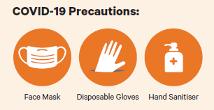

Worker and Volunteer Health (including wellbeing)
The health (including wellbeing) of our workers and volunteers during the response period and return to work is critical. In order to support WHA will continue to:
- Ensure workers who are classified as at risk are encouraged to continue to work from home (where applicable)
- Encourage workers to complete personal health checks prior to leaving home
- Continue to make workers aware of COVID-19 symptoms
- Provide regular opportunities in a safe setting for workers and volunteers to share how they are feeling
- Include wellbeing moments within team meetings
- Ensure that work tasks and the desired outcomes are realistic
- Promote the use of free wellbeing resources that are available through the Mental Health Foundation (https://www.mentalhealth.org.nz/get-help/getting-through-together/)
- Ensure workers are aware of access to Health Line (0800 3558 5453), 1737, Mental Health Foundation and our employee assistance provider available through our connection with Xero (Benestar 0800 360 364).

Responding to a Suspected or Confirmed Case of COVID-19
In the event of an individual or group identifying as a suspected or confirmed case of COVID-19, WHA will follow the following steps:
- Isolate the person from others and provide a disposable mask, if available for the person to wear
- Create a response team (2-3 people)
- Inform Healthline (0800 611 116)
- Ensure the individual/group has transport to their home or medical facility
- Physically isolate access to the known areas of movements (where practicable)
- Schedule and complete a specialist clean (including the use of PPE)
- Identify the movements of the individual/group
- Notify other potentially affected parties and trigger self-isolation procedures
- Communicate the need for further cleaning to take place with other parties (including the use of PPE)
- Request detailed registers from clubs and work with the Ministry of Health as required.

Monitoring of Controls
With a response plan in place we are able to continue working together to reduce transmission risk from COVID – 19 within our places of work and communities.
The intent of monitoring is to maintain vigilance during the changes in alert levels and achieve greater consistency in the implementation of our protocols, particularly physical distancing and hygiene.
There are a number of ways in which you can complete the monitoring of your response plan. We have defined some options below and added a template within the appendix that can be used.
You will of course have your own ideas that help achieve the desired outcome of testing the efficacy of the protocols defined within the response plan.

Monitoring opportunities
1. | Include a Health, Safety and Wellbeing question and answer section during regular catch ups with their teams (at least weekly).
2. | Use the likes of MS Teams or Trello to set up a “Parking Board” for Health, Safety and Wellbeing insights and opportunities (using the likes of Trello or MS Teams).
3. | Set up Health, Safety and Wellbeing quizzes, working with Health and Safety Representatives (where applicable) to define the content.
4. | Team Leaders & Members undertake observations of people working.  Discuss with individual team members observations of non-compliance with H&S Requirements. A template is included within the appendices of this document.
5. | Undertake a review and look at ways of improving Health, Safety and Wellbeing controls across the as part of the response plan. Reach out to your networks for insights gained from other organisations.

Appendices

Appendix 1 - Risk Assessment and Control Plan
Refer to appendix 2 for risk matrix and control hierarchy used for this assessment.
Note this risk assessment and control plan is focused on COVID 19 specific hazards, all other previously identified hazards and associated controls must still be applied.
Title: COVID – 19 Risk Assessment and Control Plan | Version Number: 1 | Issue Date: 15/5/2020 | Developed By: Enter the team names involved | Date Approved: | Approved By:
Scenario  Consider the different scenarios where transmission could take place. | Identified Hazards  What could result in harm? Either;  Non-disclosure of COVID – 19  Exposure to COVID – 19  Exposure to and transmission of COVID - 19 | Initial Risk Level  High  Moderate  Low  Very Low | Control Measures  In order of effectiveness can the hazard be;  Eliminated?  Substituted for a safer alternative?  Controlled by barriers, guards or mechanical aids?  Controlled by training and work procedures?  Controlled by use of personal protective equipment? | Residual Risk Level  High  Moderate  Low  Very Low | Responsibility for Each Control Measure
General Areas
Car Parking | Non-disclosure of COVID – 19  Exposure to and transmission of COVID - 19 | Low (Very Unlikely and major impact) | ● Car park zones allocated to individual turfs where required  ● Signage  ● Communicated to the users prior to using the facility | Low (Very Unlikely and major impact) | WHA
Access to/egress from site | Non-disclosure of COVID – 19  Exposure to and transmission of COVID - 19 | Moderate (possible and major impact) | - All pedestrian access gates cable tied open  - Arrival areas and routes for arriving and departing players defined and shared with user groups  - Signage  - Communicated to the users prior to using the facility | Low (Very Unlikely and major impact) | WHA
Changing rooms (including showers, toilets within) | Exposure to and transmission of COVID - 19 | Moderate (possible and major impact) | - Eliminate - currently closed and locked  - Signage  - Communicated to the users prior to using the facility | Very low | WHA
Toilets – general spaces | Exposure to and transmission of COVID - 19 | Moderate (possible and major impact) | - Eliminate - currently closed and locked  - Signage  - Communicated to the users prior to using the facility | Very low | WHA
Water fountains | Exposure to and transmission of COVID - 19 | Moderate (possible and major impact) | - Eliminate – Closed - via tape around the fountains  - Signage  - Communicated to the users prior to using the facility | Low (Very Unlikely and major impact) | WHA
Pavilions | Exposure to and transmission of COVID - 19 | Moderate (possible and major impact) | - Eliminate - currently closed  - Signage  - Communicated to the community | Very low | WHA
Pavilion Cafe at NHS | Non-disclosure of COVID – 19  Exposure to and transmission of COVID - 19 | Moderate (possible and major impact) | - Eliminate - currently closed  - Signage  - Communicated to the community | Very low | WHA/Neilson Catering
Sporting Edge at NHS | Non-disclosure of COVID – 19  - Exposure to and transmission of COVID - 19 | Moderate (possible and major impact) | - Eliminate - currently closed  - Signage | Very low | WHA/Sporting Edge
Dug outs at all turfs | Exposure to and transmission of COVID - 19 | Moderate (possible and major impact) | - Eliminate - currently closed  - Access taped off  - Signage  - Communicated to the users prior to using the facility | Very low | WHA
On Field Activities
Training | Non-disclosure of COVID – 19  Exposure to and transmission of COVID - 19 | Moderate (possible and major impact) | - Restrictions to a maximum number of 10 participants per group  - Restrictions to length of sessions to enable transitions between groups (10 min window)  - Contact tracing registers provided to clubs (ahead of app becoming available)  - WHA provide guidance around training and delineation to meet physical distancing requirements between groups  - Communication to user groups around suggested ways to achieve hygiene, physical distancing and communication protocols | Low (Very Unlikely and major impact) | WHA/Each club
Competition matches | Non-disclosure of COVID – 19  Exposure to and transmission of COVID - 19 | Moderate (possible and major impact) | - Eliminate - no matches at present | Low (Unlikely and major impact) | WHA
Involvement by at-risk participants or those with at-risk people within their close bubble | Exposure to and transmission of COVID - 19 | High (catastrophic and possible) | - Participants to assess whether they or anyone within their close bubble is at risk (refer to appendix 1). When identified as at risk, participants make the decision around the practicalities of returning to sport and if any additional consideration should be made (such as consulting with their family and GP).  - Participants to decide if they will not resume training or games until future alert level changes or changes in the at risk persons condition and communicate with their club  - All participants continue monitoring their own health condition  - Communicated to the community | Moderate (very unlikely and catastrophic) | Each Individual
First Aid & Emergency Scenarios
First aid | Exposure to and transmission of COVID - 19 | Moderate (possible and major impact) | - Maintain physical distancing where practicable  - Use of personal protective equipment when required to move within 2m  - First aid equipment available provided by clubs | Low (Very Unlikely and major impact) | Each club
CPR or other emergency response | Exposure to and transmission of COVID - 19 | High (catastrophic and possible) | - CPR trained personnel  - CPR procedures (following Dangers, Response, Send for Help, Airway, Breathing, Circulation, Defibrillator - https://aedlocations.co.nz/)  - First aid equipment available – including face shield | Moderate (very unlikely and catastrophic) | Each club
Evacuation from site | Exposure to and transmission of COVID - 19 | Moderate (possible and major impact) | - Physical distancing maintained during evacuation (where practicable)  - Where customers need close contact support, workers to wear protective equipment  - Assembly point large enough for potential number of people on site and achieve physical distancing  - Changes to emergency protocols communicated to workers, volunteers and customers in advance | Low (Very Unlikely and major impact) | WHA/Each club/Individual
Wellington Hockey Operations
Working on other work locations (schools, colleges) | Exposure to and transmission of COVID - 19 | Moderate (possible and major impact) | - Confirm access protocol for entry and management of site specific activities  - Continue to practise careful hygiene, wash hands thoroughly before entering and after leaving the premises  - Verification of risk controls to be undertaken by WHA CEO and WHA Staff | Low (unlikely and major impact) | WHA/Schools/Colleges
At risk workers or within close bubble of worker | Exposure to and transmission of COVID - 19 | High (catastrophic and possible) | - Workers to assess whether they or anyone within their close bubble is at risk (refer to appendix 1). When identified as at risk, participants make the decision around the practicalities of returning to sport and if any additional consideration should be made (such as consulting with their family and GP)  - Workers to decide if they will not resume training/games until future alert level changes or changes in the at risk persons condition and communicate with their club  - All workers continue monitoring their own health condition | Moderate (very unlikely and catastrophic) | WHA CEO and WHA Staff
WHA Office Areas | Exposure to and transmission of COVID - 19 | Moderate (possible and major impact) | - Daily pre – start meetings, reviewing activities that present a risk of transmission for the day  - Re-induct workers and volunteers to the workplace  - Identify segregated work areas on floor plans  - Restrict non-essential access by visitors or members of the public where possible  - Visitor to site protocols (greet at specific location, induction to site, digital sign in register use)  - All workers and site visitors to be registered on arrival using sign in register (including digitally where possible)  - Work groups to keep separated as much as possible by designating segregated work areas  - Follow specific protocols when working in close proximity (within 2m from others not in our bubbles)  - Wash and dry your hands frequently. Only use hand sanitiser for clean hands, it is not effective when hands have  - Split meal breaks and keep your distance.  - Each person to bring, their own cups, plates, utensils and return home at the end of each day  - No shared meals  - Social distancing applied during on site meetings  - Practice good hygiene, cough etiquette and maintain fresh airflow  - Signage at key decision making points (entrances, shared spaces, toilets, eating areas, vehicles)  - Verification of risk controls to be undertaken by WHA CEO and WHA Staff | Low (unlikely and major impact) | WHA CEO and WHA Staff
Work within 2 m of each other | Exposure to and transmission of COVID - 19 | Moderate (possible and major impact) | - Consider alternative methods of work  - Protective equipment (half face mask and gloves) used for duration of task  - Practice good hygiene, cough etiquette and maintain fresh airflow  - Verification of risk controls to be undertaken by WHA CEO and WHA Staff | Low (unlikely and major impact) | WHA CEO and WHA Staff
Operating WHA vehicles | Exposure to and transmission of COVID - 19 | Moderate (possible and major impact) | - Use separate vehicles as much as possible, where not practicable, the following controls apply  - Passengers allowed only if they are showing no symptoms or signs of sickness  - If possible, have a dedicated driver and same passengers for each trip  - Physical separation as much as possible and seated as far away from driver e.g. rear seat where fitted  - Signage at key decision making points  - Wipe surfaces after each trip – steering wheel, door handles (inside and out) dashboard etc  - Passengers to wash hands before getting in  - If more than one person in a vehicle then wear appropriate PPE e.g. face mask or visor  - Practice good hygiene, cough etiquette and maintain fresh airflow  - Verification of risk controls to be undertaken by WHA CEO and WHA Staff | Low (unlikely and major impact) | WHA CEO and WHA Staff
Domestic travel | Non-disclosure of COVID – 19  Exposure to and transmission of COVID - 19 | Moderate (possible and major impact) | - All domestic travel must be planned prior to departing  - Hygiene PPE to be available for duration of travel period  - Maintain and monitor work team bubbles  - Clean any shared tools, plant and equipment before departure and regularly where in use whilst away  - Ensure protocols are maintained at accommodation and for any meal arrangements Contact accommodation providers to understand on site controls in place  - Utilise laundry facilities and cleaning facilities at accommodation  - Verification of risk controls to be undertaken by WHA CEO and WHA Staff | Low (unlikely and major impact) | WHA CEO and WHA Staff
Workers/Participants returning home | Exposure to and transmission of COVID – 19 to whanau | Moderate (possible and major impact) | - Recommended actions:  - Plan your return to home prior to entering your home/residence  - Where possible, do not take items used during work/hockey activities into the residence (work equipment, hockey equipment, cups, drink bottles)  - Items that are taken into the home/residence should be decontaminated first (alcohol wipes) or kept in a zip lock bag  - Footwear should be kept outside the house/residence  - Avoid contact prior to decontamination  - Clothes to be removed as close as possible to entrance into home/residence  - Clothes places in washing machine – don’t start the cycle  - Hot shower and wash with soap/body wash  - Following shower, wash clothes on hot wash cycle  - Verification of risk controls to be undertaken by WHA CEO and WHA Staff | Low (unlikely and major impact) | WHA CEO and WHA Staff
Other Businesses (PCBUs)
Deliveries to and from site | Exposure to and transmission of COVID – 19 to whanau | Moderate (possible and major impact) | - Signage | Low (unlikely and major impact) | WHA CEO and WHA Staff
Any other tenants?
Contractor Work in shared spaces | - Exposure to and transmission of COVID – 19 to whanau | Moderate (possible and major impact) | - Signage | Low (unlikely and major impact) | WHA CEO and WHA Staff
Contractor Work in restricted spaces | - Exposure to and transmission of COVID – 19 to whanau | Moderate (possible and major impact) | - Signage | Low (very unlikely and major impact) | WHA CEO and WHA Staff

Appendix 2 – Risk Matrix and Control Hierarchy
Risk matrix
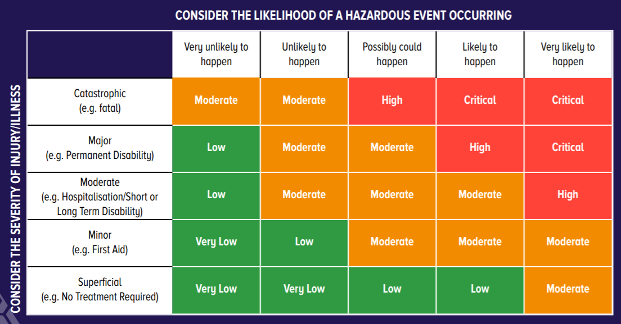

Retrieved from - https://www.sitesafe.org.nz/globalassets/guides-and-resources/risk-guide-web-final.pdf

Control Hierarchy
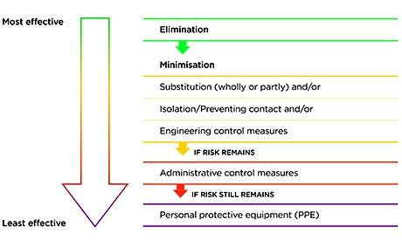
Retrieved from - https://worksafe.govt.nz/topic-and-industry/hazardous-substances/managing/risk-management/

Appendix 3 – Monitoring Template

Team Details
Team name: |  | Team Manager:
 |  | Team Members Involved:
Work site: |  | Date:
Nature of the work:

Communication | Y/N | Hygiene and cleaning protocols | Y/N
Signage installed reinforcing key protocols in critical decision points (near common use equipment/surfaces, toilets, food prep areas) |  | Hygiene protocols been shared with the team
Workers have been made aware of transportation protocols to reduce transmission risk |  | Workers can demonstrate the hygiene and cleaning protocols shared
A record of workers entering and exiting site is being maintain and accurate (for contact tracing purposes |  | Regularly used equipment, tools, surfaces are being cleaned regularly after use and more thoroughly at the end of the day
Total number of modifications to make to our response plan from this section >

Workplace conditions | Y/N | Worker health and wellbeing | Y/N
Hand washing stations, provision for additional hand sanitiser and disinfecting products has been provided |  | Workers who are classified in the ‘at risk’ category are encouraged to work from home (where applicable)
Workers all have access to sanitation, nutrition and clean water during their shift |  | Workers have been notified of the need to complete personal health checks prior to leaving home
The layout of the site has been adjusted to enable physical distancing |  | Workers have been made aware of COVID-19 symptoms
Close contact work (within 1 m) has been assessed and protective equipment provided for the scenario (if it was to arise) |  | Workers are aware of access to health line (0800 358 5453, 1737, mental health foundation and our employee assistance provider (Benestar 0800 360 364, Xero provided programme)
Shared spaces (like lunchrooms) have been assessed and adjustments made to enable physical distancing and reduced traffic (staggered meal breaks) |  | Workers are aware of the Wellbeing tools and resources available
The use of shared appliances and equipment has been reduced (cutlery, utensils, cups etc) |  | Regular team meetings are taking place and both wellbeing moments and a health and safety question and answer section has been included
Designated delivery areas have been set up that enable physical distancing rules
Total number of modifications to make to our response plan from this section >>

Personal Protective equipment | Y/N | Emergency procedures | Y/N
The type of protective equipment has been identified in line with Ministry of Health Guidance |  | Protocols have been shared with workers around responding to an exposure event
Workers have been provided guidance on how and when to use protective equipment effectively |  | Any change to evacuation protocols and assembly points have been identified and communicated to workers
Protective equipment is available to workers in all settings (including off site activities) |  | Lone worker protocols have been implemented and communicated to workers
Disposal of used protective equipment has been defined
Total number of modifications to make to our response plan from this section >

Identified modifications to the response plan

List below the modifications that need to be made to the COVID-19 response plan for your team.

Appendix 4 – Personal Health Flowchart
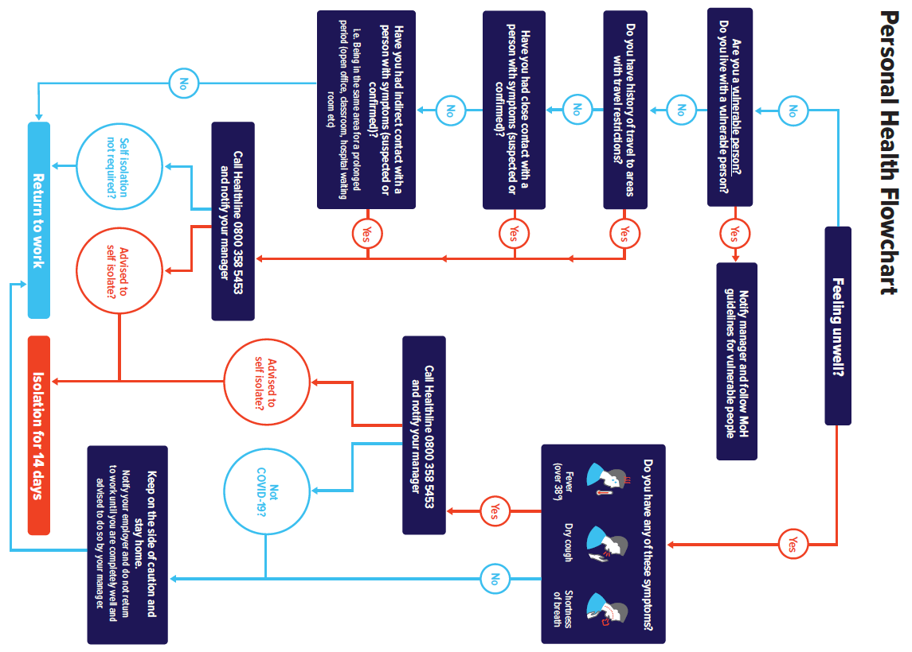

Appendix 5 – Cleaning Regime Example

Cleaning and disinfectant Checklist - NHS Administration Block
Day :
SR | Cleaning Points | Resp. | Method | Freq. | User initial/time completed
1 | Kitchen bench | User | Disposable cloth & disinfectant | After each use
2 | Electric Jug | User | Disposable cloth & disinfectant | After each use
3 | Coffee Machine | User | Disposable cloth & disinfectant | After each use
4 | Washing brush washed | User | Hot water and washing liquid | After each use
5 | Fridge door and handle | User | Disposable cloth & disinfectant | After each use
6 | Microwave | User | Disposable cloth & disinfectant | After each use
7 | Toilets / Wash Room | All | Disposable cloth & disinfectant | Hourly
8 | Board room | User | Disposable cloth & disinfectant | After each use
9 | Lino floor | All | Not sure yet? | End of day
10 | Door Handles | All | Disposable cloth & disinfectant | Hourly
11 | Work space - screens, tables, keyboard, | User | Disposable cloth & disinfectant | Hourly
12 | Photocopier | User | Disposable cloth & disinfectant | After each use
12 | Sign in pen | User | Disposable cloth, disinfectant | After each use
11 | Empty rubish bins | User | Empty into the big WM bins, wipe down with Disposable cloth &disinfectant | At the end of each day

Appendix 6 – Work Safe NZ Template
T E M P L A T E

Name of CEO: Lisa Jones

CEO approval:

Name of worker representative:
Worker representative consultation:

Business name: Wellington Hockey Association
Division/group:
Date completed:
Date distributed:
Revision date:

Company details

COVID-19 safety plan
Use this form to document your thinking about how you and your workers will keep safe at work during the COVID-19 pandemic.
Provide as much information in response to each question as possible. This information will help your workers and other people
to know exactly what to do and what to expect.
The COVID-19 pandemic is an evolving situation – review your plan regularly and make changes as required.
There is guidance on what to think about when you’re planning a safe return to work here: http://www.worksafe.govt.nz/
You don’t need to send this plan to WorkSafe for review or comment.

Refer to the WorkSafe guidance for constructing a COVID-19 safe work plan for full details.

 |  | DESCRIBE WHAT YOU WILL DO | WHO IS RESPONSIBLE
What will be done to manage risks from restarting business after lock-down? |  | Consider: Changed workforce, changed rosters, hygiene requirements (surfaces, separation, toilet), maintenance, ventilation systems.  Example: Restart the line - carry out restart procedure and sterilise all touch surfaces.  Remain working remotely until Alert Level 2  Ensure the separation distance of minimum of 1 metre is possible and adhered to  Maintain good hygiene, particularly hand hygiene and good cough/sneeze etiquette  Implement increased cleaning schedule and hygiene requirements including disinfecting surfaces. Relevant posters will be placed around the work environment to remind our team over time. Our implementation and ongoing use of this regime will be discussed at our weekly team meeting. Any adjustments needed will be documented and implemented urgently  Keep daily record of who attends the property for facilitate contract tracing  Support our team to self-isolate if they have with flu like symptoms  Support our team to not attend work if sick  Ensure our team are aware of the exit procedure if someone is suspected to have had exporsure or suspected exposure to COVID-19 | All team members
How will you ensure all your workers know how to keep themselves safe from exposure to COVID-19? |  | Consider: Providing guidance, meetings to discuss distancing and hygiene, regular review.  Example: Ensure our procedures are up to date by a daily review of Ministry of Health guidance.  A 1 on 1 call will be held with each employee to ascertain their understanding of how to stay safe from exposure to COVID-19 and how to keep themselves safe. If any areas of concerns are identified these will be rectified prior to the employee entering the work place  Ensure our procedures are up to date by a daily review of Ministry of Health guidance by 10am. We will ensure any change/s are communicated verbally to the team (ensuring each individual understands the change/s) within 1/2 hour and follow up with email  Weekly team meetings with be held, ensuring physical distancing. H & S is our no 1 Agenda item. Ensuring we are all keeping safe from exposure to COVID-19 will be discussed | CEO  Administrator
 | DESCRIBE WHAT YOU WILL DO |  | WHO IS RESPONSIBLE
How will you gather information on the wellness of your staff to ensure  that they are  safe to work? | Consider: Daily health screening check, discussing options with workers, follow-up  procedures for ill workers, contact tracing information.  Example: To find out if workers are well when they come to work, we will ask each worker  basic questions about their physical and mental health.  Regular contact has been in place since level 4 ensuring our team are safe and well  A 1 on 1 phone call will be held with each employee, prior to attending the office, to gain information on their wellness and they are safe to return to work  Clear guidelines will be set determining what will be considered to determine if someone should stay home will be put in place and communicated prior to our team attending the office. This will assist our team to make decisions  I will sit down with each employee and ensure their understanding of these guidelines and are committed to following them - CEO  I operate an open-door policy where I ensure my team feel safe to follow the guidelines and to communicate openly with me - CEO |  | CEO
How will you operate your business in a way that keeps workers and others safe from exposure  to COVID-19? | Consider: Who needs to be in the workplace, worker input into different ways of working, what other people or businesses you’ll have to interact with, ensuring separation distances, disinfecting surfaces, shared equipment, equipment for remote workers, training requirements, physical separation or PPE requirements, worker transport.  Example: We will review guidance on the Ministry of Health website and to be sure we are cleaning surfaces the right way with the right disinfectant.  Remain working remotely until Alert Level 2  Ensure the separation distance of minimum of 1 metre is possible and adhered to  Maintain good hygiene, particularly hand hygiene and good cough/sneeze etiquette  Implement increased cleaning schedule and hygiene requirements including disinfecting surfaces. Relevant posters will be placed around the work environment to remind our team over time. Our implementation and ongoing use of this regime will be discussed at our weekly team meeting. Any adjustments needed will be documented and implemented urgently  Keep daily record of who attends the property for facilitate contract tracing  Support our team to self-isolate if they have with flu like symptoms  Support our team to not attend work if sick  Ensure our team are aware of the exit procedure if someone is suspected to have had exporsure or suspected exposure to COVID-19 |  | CEO to confirm who needs to be in the workplace and when the team returns.  Administrator to review procedures and order supplies  Cleaners to use the new supplies and follow new cleaning procedures
How will you manage an exposure or suspected exposure to COVID-19? | Consider: Isolation procedures, gathering and using workplace contact tracing information,  clean down procedures, contacting Healthline.  Example: Arrange safe transport home immediately and provide all workers with advice  on contacting GP and/or Healthline.  We will arrange safe transport home immediately. All staff will be advised to vacate the building and be advised to contact their GP and/or Healthline  If a worker is removed from site due to the exposure or suspected exposure a specialist clean will be completed in the area/s identified where the worker was working and has accessed. These areas will be isolated until a specialist clean has taken place  All equipment will be cleaned down and disinfected, concentrating on points of contact such as handles, kitchen and toilet etc.  Our team will only return to work after this is completed |  | CEO or team member who is present
 | DESCRIBE WHAT YOU WILL DO |  | WHO IS RESPONSIBLE
How will you evaluate whether your work processes or risk controls are effective? | Consider: Adapting plans as you find better/easier ways to do things, how to ensure workers are raising concerns or solutions, conducting regular reviews of your plan, communicating changes.  Example: We need workers’ feedback and some speak little English, so we will team  up workers with buddies who are more fluent in English at team meetings.  Weekly team meetings with be held, ensuring physical distancing. H & S is our no 1 Agenda item. Ensuring we are all keeping safe from exposure to COVID-19 and our implementation and ongoing use of our plan will be discussed. Any adjustments needed will be documented and implemented urgently |  | CEO and all team members
How do these changes impact  on the risks of the work that you do? | Consider: With workers, review existing critical risks and whether work practice changes  will affect current risk management, are any new critical risks introduced due to changes  in worker numbers, work practices, what new risk controls are required?  Example: Regular check-ins with workers about how they’re coping with the change to  shift work. |  | CEO

Appendix 7 – Worker Re-induction Fact Sheet

Reconnecting to our places of work
Date: May 2020
Subject: Returning to work
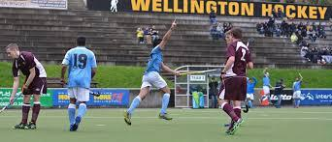
This fact sheet can be used as part of returning team members to places of work and is focused on reconnecting team members to safe and healthy ways of working, including gradually returning to high risk activities.
Action Required
- Run through this fact sheet and check off with the team against the bullet points below;
- We’ve reconnected to WHA’s commitment to health and safety
- I’ve been reminded around the specific hazards present in my place(s) of work
- We’ve covered what control measures that we have in place for the hazards
- We’ve talked through the specific controls and protocols that we need to follow that relate specifically to COVID 19. Refer to response plan.
- For high risk activities we have identified a pathway of starting with lower risk activities before returning to higher risk activities, including if extra supervision of the task could help
- Emergency scenarios and procedures have been covered
- I know who the fire warden(s) and first aider(s) are
- I’m confident around how and who to report events to
- I know that we all have a role to play in creating and maintain safe and healthy places of work.
- Ask workers to sign off on the last page as they return to work (understanding that you may have workers returning at different stages).
Why are we doing this?
It is essential that as workers return to places of work that they reconnect to our health and safety systems, along with what healthy and safe ways for working are.

COVID specific control measures
- Communication protocols – personal health checks, daily pre start meetings, sign in and out process, contact tracing (if applicable).
- Hygiene protocols – use of hand washing station, printers, toilets, lunch rooms, meeting rooms, interactions with other business units, different team shifts and contractors.
- Protective equipment available, when and how to use – masks, gloves, sanitiser, sanitising wipes.
- Protocols for the use of tools, plant and equipment.
- Evacuation protocols – any alterations to emergency evacuation protocols
- General – changes to smoking areas, accessing work spaces.

Need further information?
Connect with the following:
- Your manager or supervisor
- Work Safe New Zealand website
- Ministry of Health website.

What do I need to do?
For this toolbox talk, we need you to acknowledge that you have covered the power point presentation and been provided a thorough re-induction to site(s).
Date | Name | Signature
 | Add more rows if you need too.

Appendix 8 – Contact Tracing Register
Contact tracing log for Wellington Hockey Association
This information is being collected to assist in the management of the COVID-19 pandemic.
It will be given to the Ministry of Health and/or the District Health Board on request in the event that it is required for contact tracing purposes.
We will not use it for any other purpose and will destroy this record after four weeks. It will be kept on this premise in a safe and secure location.
Under the Privacy Act 1993 you have a right to access and correct any information we hold about you.
Date | Full Name | Address | Email | Phone | Time in | Time out

Referenced material
- Work Safe New Zealand – risk management principles retrieved from https://worksafe.govt.nz/topic-and-industry/hazardous-substances/managing/risk-management/
- Sport New Zealand – play, sport and recreation at Level 2 retrieved from https://sportnz.org.nz/assets/Uploads/Play-Active-Recreation-Sport-Alert-Level-3.pdf
- Unite against COVID – 19 – alert level framework retrieved from https://covid19.govt.nz/alert-system/covid-19-alert-system/
- Work Safe New Zealand – COVID – 19 safety plan retrieved from https://worksafe.govt.nz/dmsdocument/27551-covid-19-safety-plan-template-pdf-version/latest
- Ministry of Health – personal protective equipment requirements retrieved from https://www.health.govt.nz/our-work/diseases-and-conditions/covid-19-novel-coronavirus/covid-19-information-specific-audiences/covid-19-advice-workers-including-personal-protective-equipment/personal-protective-equipment-use-non-health-workers
- Unite against COVID – 19 – reference material and ready to print material – retrieved from https://covid19.govt.nz/resources/
- Construction Health and Safety New Zealand – reference material and ready to print material - retrieved from https://www.chasnz.org/resources
- Site Safe New Zealand – Risk Matrix Example retrieved from https://www.sitesafe.org.nz/globalassets/guides-and-resources/risk-guide-web-final.pdf
- Sport NZ - Contact Tracing Information -https://sportnz.org.nz/covid-19/sector-advice/contact-tracing/

