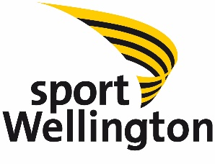
Sport Wellington Position Description
POSITION: | Evaluation and Insights Assistant
BUSINESS UNIT: | Futures
REPORTING TO: | Evaluation and Insights Manager
DIRECT REPORTS: | 0 | INDIRECT REPORTS: | 0
LOCATION: | Sport Wellington, Level 1, 223 Thorndon Quay, Wellington  Pelorus Trust Sports House, Seaview, Lower Hutt
HOURS: | 12 hours per week – fixed term agreement until 26th June 2020
REMUNERATION: | Remuneration: $20hr - $22hr
DATE UPDATED: | July 2019

SPORT WELLINGTON VISION
Everyone in the greater Wellington region has a life-long involvement in sport and active recreation.

SPORT WELLINGTON PURPOSE
Lead the Wellington region’s sport and active recreation community to enable people to be more physically active.

STRATEGIC OUTCOMES
- A healthy, active region
- A sustainable sport and active recreation system
- Sport Wellington is an effective regional leader

SPORT WELLINGTON VALUES
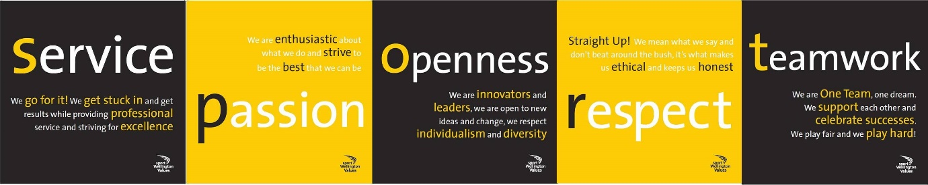
PURPOSE OF POSITION
To help collect, analyse and disseminate data and information to support Sport Wellington’s programmes and initiatives. To provide support for report writing ensuring Sport Wellington communicates its impact well. To support planning, monitoring and evaluation of programmes and initiatives.

KEY TASKS
Evaluation | - Support effective monitoring and evaluation plans and activities  - Manage evaluation tools including Excel and Survey Monkey  - Support staff with surveys and general data capture  - Assist with reporting, case studies and success stories  - Support creation of evaluation plans  - Analyse data, extract findings and recommendations
Insights | - Provide insights and recommendations to relevant internal teams based on consumer information and behaviour in relation to participation in sport and active recreation  - Conduct horizon scanning and provide evidence synthesis  - Support staff to complete reports that show Sport Wellington’s impact on the sport and physical recreation sector of Wellington  - Identify, recognise and share best practise organisations, programmes, initiatives, etc using appropriate formats.
Communication | - Support communication of new research and best practices regarding barriers, motivations, behaviour change, quality opportunities in sport and active recreation  - Collate, share and store relevant information and resources using up-to-date technology and other Sport Wellington mediums.
Wider Sport Wellington contribution | - Contribute to Community Sport, Healthy Lifestyles, KiwiSport, Events and Wairarapa projects as necessary.  - Work effectively across the organisation with a focus on developing strong relationships and collaboration.

KEY RELATIONSHIPS
INTERNAL | EXTERNAL
- Evaluation and Insights Manager  - Future Plans and Projects Manager  - CEO  - General Manager  - Support Services Manager  - Business Unit Managers  - Sport Wellington staff | - Regional Sports Trusts  - Regional Sports Organisations  - College Sport Wellington  - Other stakeholders

BEING PART OF THE WIDER SPORT WELLINGTON TEAM
- Actively and positively participate as a member of the team, supporting the philosophy and culture of Sport Wellington and commit to continued personal and professional development.
- Proactively look for opportunities to improve the operations of Sport Wellington and collaborate with others.
- Perform any other duties as needed and support other Sport Wellington initiatives such as events (Round the Bays, SPOY) and KiwiSport.
- Comply with and support all health and safety policies, guidelines and initiatives. Ensure all incidents, injuries and near misses are reported into our H&S reporting tool (Mango).
- Adhere to all Sport Wellington procedures, policies, guidelines, and standards of integrity and conduct.
- Demonstrate a commitment to and respect for the Treaty of Waitangi and incorporate these into your work.
- Provide on-going information and success stories to Sport Wellington and key stakeholders on progress against outcomes.
- Assist in the implementation of a “whole of business” knowledge management system and processes to capture, develop, share and effectively use knowledge across the organisation to inform decisions.

PERSON SPECIFICATION
ESSENTIAL SKILLS | ESSENTIAL ATTRIBUTES
- Experience in the analysis of research & information and translating to meaningful and actionable insights  - Qualification and/or relevant experience in Research and Evaluation; or transferable skills (e.g. from university projects).  - Excellent computer skills including Microsoft Excel and able to learn new technology quickly (e.g. SharePoint, Planner, Dynamics 365, etc.)  - Knowledge of survey methodology and experience using survey tools e.g. Survey Monkey.  - Excellent writing and grammar skills and the ability to write concisely, clearly and logically for a wide range of audiences.  - Understanding of the sport and physical recreation sector.  - Ability to manage multiple milestones and deadlines. | - Ability to build rapport and maintain relationships  - Adaptability/Flexibility  - Self-motivation, resilience, and drive  - Teamwork  - Professionalism  - Accuracy and attention to detail  - Values sport and active recreation for themselves and others

SPORT WELLINGTON COMPETENCIES
Leadership is about embedding the vision of Sport Wellington and making it real for everyone. It is about creating an environment where people are valued and are encouraged and inspired to contribute fully to Sport Wellington’s success.
Managing resources is using the right mix of financial, people and physical resources to achieve Sport Wellington’s goals.
Getting things done means having a can-do attitude and demonstrating a commitment to completing responsibilities on time, delivering quality and positive results.
Teamwork is working well with others to achieve goals and having relationships of mutual trust and understanding with the people you work with.
Customer service means treating internal and external customers with respect, courtesy and dignity. This involves identifying needs and expectations of all customers, and doing what we say we will do, in a quality manner.
Problem solving is identifying a potential risk or problem, knowing when and where to seek help, managing the risk and proactively finding a solution and managing the problem.
Creativity and innovation is about improving the way we do things. It means having an environment where people are encouraged to be creative, resourceful and to generate ideas.
Technical know-how is knowing how to do your job, keeping up-to-date with new developments and carrying out the requirements of your job to deliver outstanding services.

